Profile Improvement in Iterations

Iteration 1

ITERATION 1 — Solid & Basic (Ready for Outbound)

Timeline: 1–2 weeks

1. Profile Setup
- Clean headshot
- Outcome-focused banner
- Clear headline
- Short About section (problem → outcome → proof → CTA)
- Add 1 featured item (case or one-pager)

2. Network Building (Basic)
- Follow 20–30 ICP founders
- Follow 10–20 creators/experts
- Send 5–10 targeted requests/day
- Use simple personalized connection message

3. Supporting Content
- Post 2 times/week
- 1 proof post
- 1 problem → solution post
- Comment on 3 ICP posts/day

4. Light Outbound
- Engage twice before DM
- Send simple value-first message
- 2 follow-ups max

5. KPIs
- +100–200 connections
- 4 posts in 2 weeks
- 3 comments/day
- 1–3 meetings booked

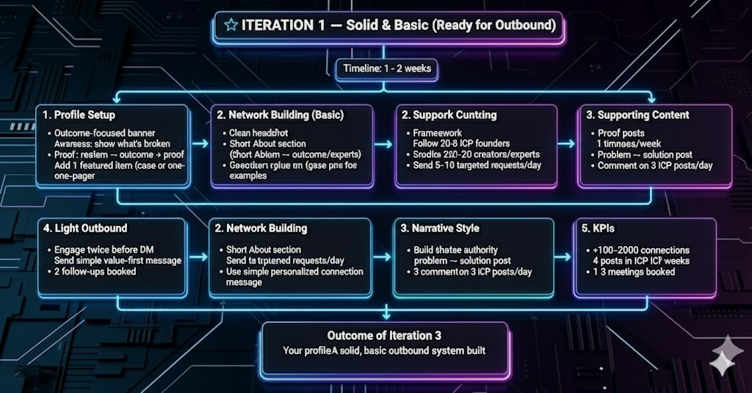

Iteration 2

ITERATION 2 — Improved & Refined (Scale Outbound)

Timeline: 2–8 weeks

1. Profile Enhancements
- Updated headline with micro-proof
- Expanded About section with mini-case bullets
- 2–3 items in Featured
- Add 2 recommendations

2. Smarter Network Building
- Segment: Primary ICP / Secondary ICP / Partners
- Add 10–15 connections/day
- Build lists using filters (or Sales Navigator)
- Engage consistently with priority ICPs

3. Stronger Content System
- 3–4 posts/week
- Weekly sequence: Authority → Problem → Proof → Story
- Test different hooks
- Repurpose into articles/snippets

4. Refined Outbound Sequence
- Multi-touch flow: Connect → Engage → Value DM → Case DM → Soft CTA
- Provide checklists, one-pagers, mini-case studies

5. Proof System
- Create 3 case study one-pagers
- Track before/after metrics for every project

6. KPIs
- +400–1,000 targeted connections/month
- Reply rate: 6–15%
- 5–15 meetings/month
- 1–4 clients/month

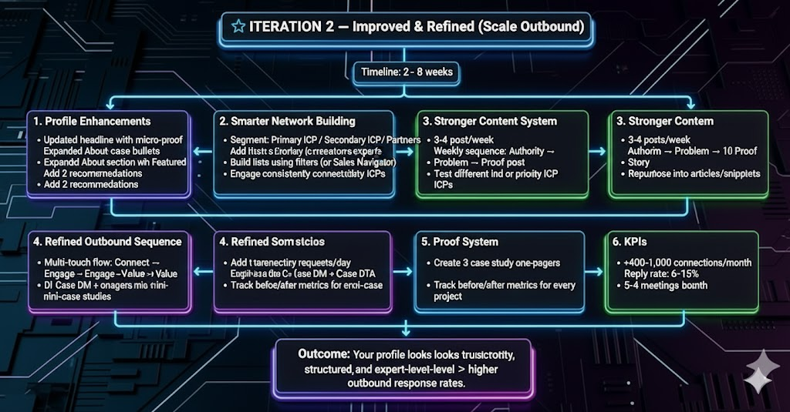

Iteration 3

ITERATION 3 — Polished & Optimized (High-Converting Machine)

Timeline: 3–9+ months

1. Enterprise-Level Profile
- Strong social proof in headline
- Case study at top of About
- 4 featured assets (video, case study, article, lead magnet)
- 5+ recommendations from decision-makers
- SEO keywords added

2. High-Precision Network Building
- Sales Navigator + Boolean lists
- 15–25 connection requests/day
- Build partner/referrer ecosystem
- Host/lead ICP groups or newsletters

3. Advanced Content Engine
- 4–6 posts/week
- Weekly article or newsletter
- Objection-killer posts
- Short-form video content
- Repurpose across channels
- Run paid boosts on top-performing posts

4. High-Conversion Outbound
- Multi-channel cadence (LinkedIn + email + retargeting)
- Personalized 3-line intros
- Send dynamic one-page value documents
- Book 20–100 meetings/month (team dependent)

5. Proof & Authority Growth
- Publish monthly case studies
- Host webinars/workshops for ICPs
- Co-create content with industry partners

6. KPIs
- +1,000 qualified connections/month
- Outbound reply rate: 10–25%
- Meetings: 20–100/month
- 3–15 clients/month
- Case study: 1/month

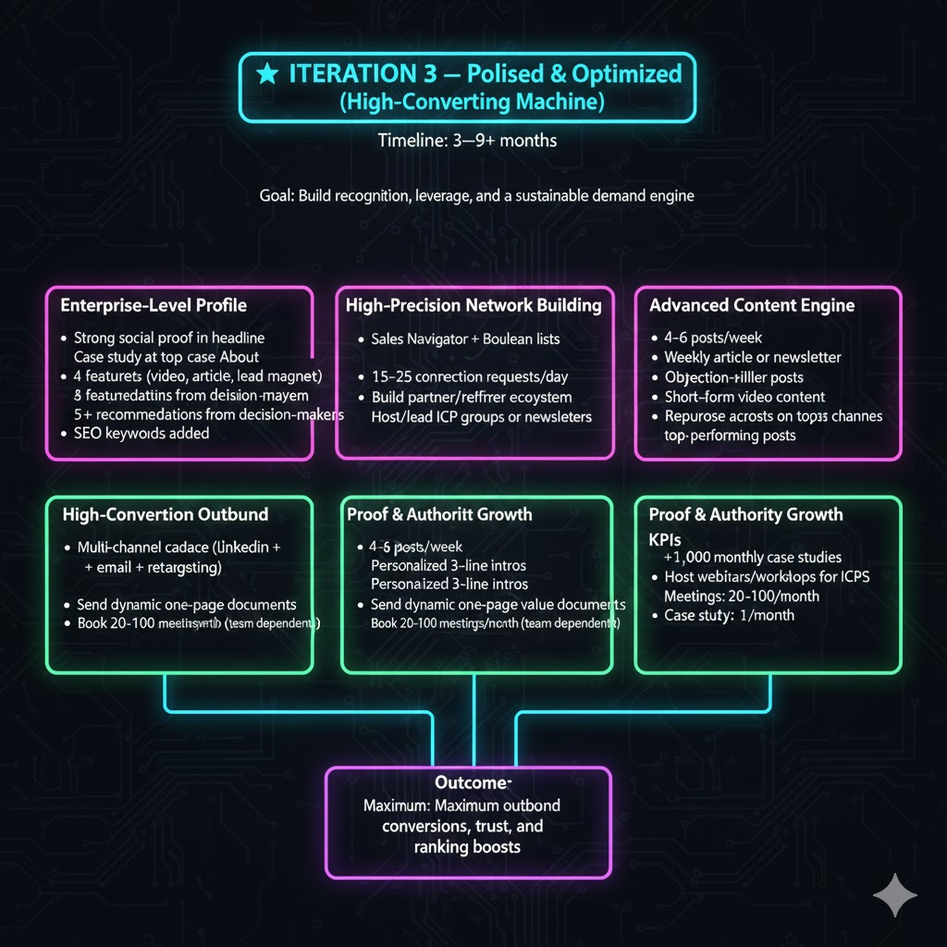

Strategy

⭐ THE 3-DIMENSION LINKEDIN GROWTH FRAMEWORK

(D1: Profile • D2: Network • D3: Content + Outbound)

✅ DIMENSION 1 — PROFILE FOUNDATION

Goal: Make the profile trustworthy in under 5 seconds.

1. Positioning (Clarity Layer)
Each team member must instantly communicate:
- Who they help
- What problem they solve
- What outcome they deliver
If these three aren’t clear, the profile fails.

2. Core Profile Elements (Structure Layer)
Every team member should have:
• Headline formula:
“I help [ICP] achieve [Outcome] using [Method].”
• Banner:
Clear, simple text: “Helping [ICP] achieve [Outcome].”
• About section structure:
- ICP + problem
- Outcome + solution
- 1 line of proof
- CTA: “DM me ‘X’ for a free audit”
• Featured section:
- Case study (PDF or post)
- Top-performing post
- Offer one-pager / landing page
• Experience:
- Who they help
- What they deliver
- 1–2 proof statements

🌟 DIMENSION 2 — NETWORK & VISIBILITY ENGINE

Goal: Build a network of people who can become clients or amplify visibility.

1. Target Groups
Each team member should connect with:
- ICPs (Founders, CEOs, CMOs, Heads of Growth)
- Node accounts (Large creators your ICP follows)
- Peers/partners (People who can refer clients)

2. Daily/Weekly Networking Rules
- Send 10–15 targeted connection requests/day
- Follow 20–30 industry creators/week
- Engage with 5–10 ICP posts/day
- Maintain 30–60 min/day for engagement

3. Visibility Rules
- Prioritize commenting on posts from ICPs
- Avoid engaging with irrelevant creators
- Support each other’s posts (smart engagement pods)

🔥 DIMENSION 3 — CONTENT & OUTBOUND CONVERSION

Goal: Build demand + start conversations + generate booked calls.

1. Content System (Demand Layer)
Post 2–4 times/week, using:
- Authority posts
- Problem → solution posts
- Proof posts
- Story posts
- Light CTA posts

2. Outbound System (Conversion Layer)
Process:
- Send personalized connection request
- Warm up (2 light engagements)
- First DM → value first (“Want a short checklist?”)
- Follow-up → add proof
- Convert → “10-min audit / quick check”
Never pitch first. Always start with value.

🎯 FINAL SUMMARY (1-Slide Version)

D1: Profile
→ Clear offer, proof, CTA.

D2: Network
→ Connect with ICPs, node accounts, peers.
→ Daily engagement.

D3: Content + Outbound
→ Consistent posting + value-first messaging.
→ Convert through audits, insights, and proof.
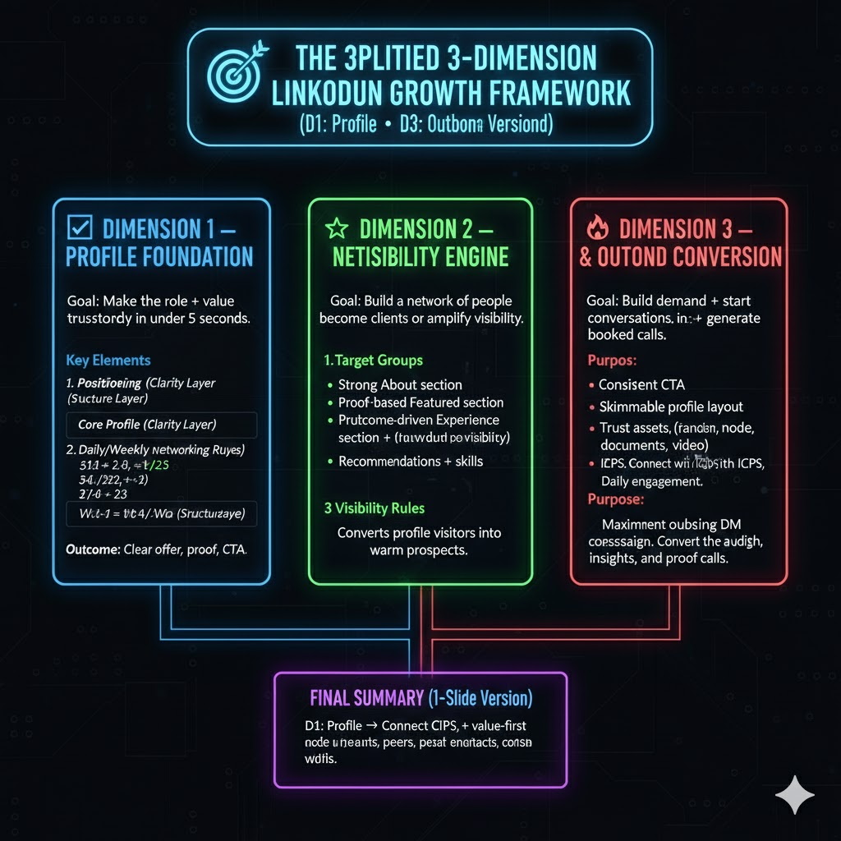

Profile

P Iteration 1

ITERATION 1 — Strong Basic Version (Outbound-Ready Essentials)
Goal: Make your profile clear, credible, and ready for outbound.

1. Headline — Clear & Outcome-Focused
- Format: I help [ICP] achieve [Outcome] using [Method].
- Purpose:
  - Shows exactly what you do in 1 second
  - Makes outbound messages feel more relevant
  - Improves conversions from profile views

2. Banner — Simple but Clear
- Include:
  - What you do
  - Who you help
  - 1-line outcome
  - Soft CTA (optional)

3. Profile Photo — Professional
- Clean background
- Good lighting
- Eye contact
- Sharp image

4. About Section — Short & Customer-Focused
- Who you help
- The problem they face
- The outcome you create
- Simple CTA
- Keep to 5–7 lines

5. Experience — Clear & Outcome-Based
- State what you do
- Who you help
- Key outcomes delivered
- Keep corporate text minimal

6. Featured Section — Minimum Required
- Add:
  - Your offer (1-page doc)
  - A simple CTA asset

7. Contact Information — Easy to Access
- Email
- Website (even if incomplete)
- Optional: Calendly link

Outcome of Iteration 1
- Profile becomes “outbound-ready” → clear, credible, and frictionless.

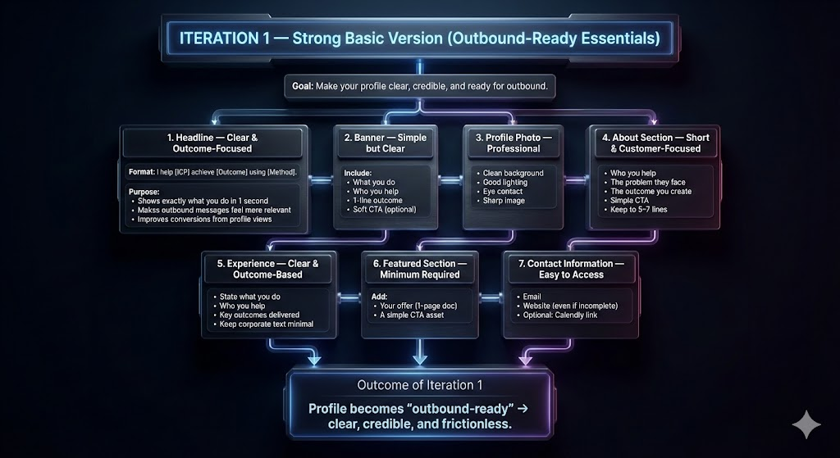

P Iteration 2

ITERATION 2 — Improved & Refined Version (Trust + Depth + Authority)
Goal: Increase credibility and trust to improve reply rates.

8. Headline Upgrade — Add Authority
- Include:
  - Clear value
  - Your unique approach
  - Niche clarity

9. Banner Upgrade — Add Trust
- Add:
  - Method or framework name
  - Social proof (if available)
  - Clear CTA
  - Strong niche positioning

10. About Section — Expand but Keep Skimmable
- Pain point of your ICP
- Why common solutions fail
- Your unique method
- Expected outcomes
- Micro-proof (even small wins)
- CTA

11. Featured Section — Add Proof Assets
- Case study or micro-proof
- 1-page outbound framework
- Before/after example
- “How I Work” PDF

12. Experience Section — Convert Into Authority
- Add:
  - Your system
  - Your workflow
  - Key outcomes
  - Who you’ve helped

13. Skills — Increase Search Ranking
- Add 10–15 relevant skills such as:
  - Outbound Lead Generation
  - LinkedIn Optimization
  - Direct Response Messaging

14. Contact Info — Fully Professional
- Email
- Website
- Calendly
- Location

Outcome of Iteration 2
- Profile looks trustworthy, structured, and expert-level → higher outbound response rates.

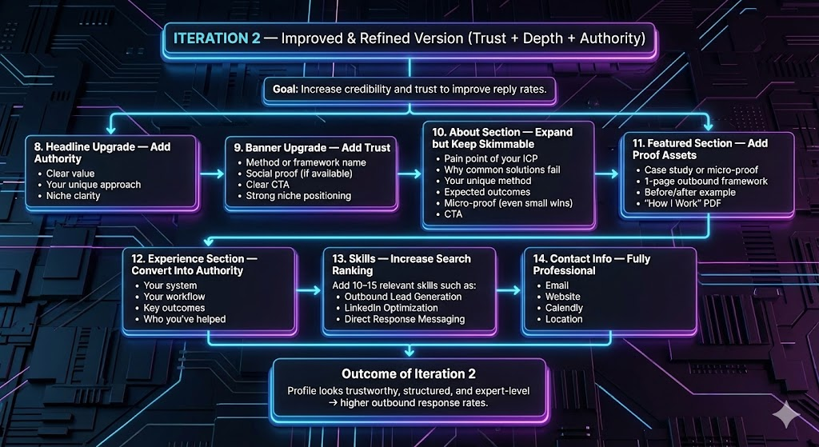

P Iteration 3

ITERATION 3 — Fully Polished, High-Authority Version (Maximum Conversion)
Goal: Turn the profile into a conversion engine for outbound traffic.

15. Final Headline — Authority + System Name
- Format:
I help [ICP] achieve [Outcome] with [System Name] → [Proof/Guarantee].

16. High-End Banner — Branded & Premium
- Brand colors
- Clean typography
- 1 strong transformation
- 1 proof element
- CTA
- Optional: logo

17. About Section — Full Conversion Copy
- Hook (problem)
- Why the problem matters
- Market mistakes
- Your system
- Results/proof
- How you work
- CTA

18. Premium Featured Section — Conversion-Focused
- Offer page
- Case study library
- Your framework (named system)
- Call booking link

19. Recommendations — Aligned With Your Offer
- Ask for testimonials mentioning:
  - Outbound
  - Messaging
  - Lead generation
  - Results

20. Projects — Add Extra Authority
- Add small projects like:
  - “Outbound Optimization Framework”
  - “Cold Messaging Audit System”
  - “Prospect Research Method”

21. Short Intro Video (Optional But Powerful)
- 20–30 seconds covering:
  - Who you help
  - What problem you solve
  - What results you create

22. Skimmability — Make Everything Easy to Read
- Short paragraphs
- Bullet points
- Clear section breaks
- No text walls

23. CTA Alignment — Everywhere
- Same CTA in:
  - Headline
  - Banner
  - About
  - Featured
  - Experience

Outcome of Iteration 3
- Your profile looks premium, authoritative, and designed to convert cold leads into booked calls.

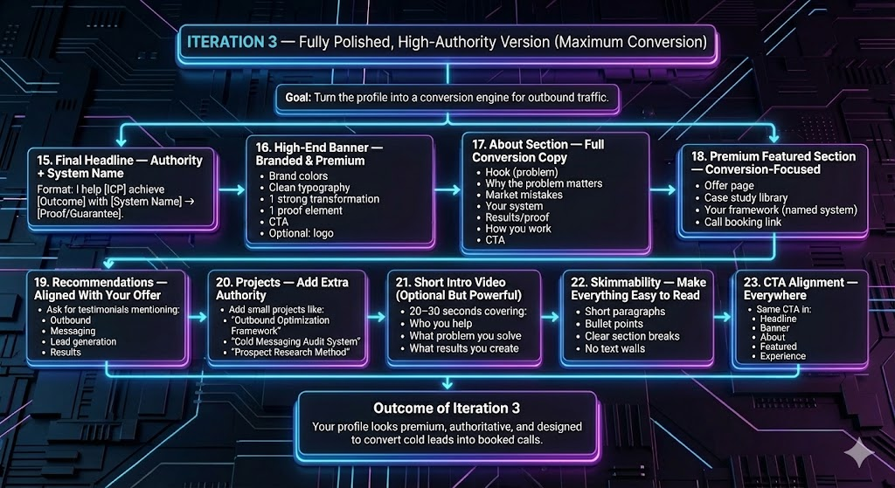

P Strategy

🎯 SIMPLIFIED 3-DIMENSION OUTBOUND PROFILE STRATEGY

🟦 DIMENSION 1 — IDENTITY CLARITY
Goal: Make your role + value instantly understandable.

Key Elements
- Clear headline
- Clear banner message
- Professional photo
- Outcome-based experience titles

Purpose
- Helps cold leads immediately recognize your relevance.

🟩 DIMENSION 2 — TRUST FOUNDATION
Goal: Build credibility so cold leads feel safe replying.

Key Elements
- Strong About section
- Proof-based Featured section
- Outcome-driven Experience section
- Recommendations + skills

Purpose
- Converts profile visitors into warm prospects.

🟥 DIMENSION 3 — CONVERSION DESIGN
Goal: Turn visitors into replies and booked calls.

Key Elements
- Consistent CTA
- Skimmable profile layout
- Trust assets (frameworks, documents, video)
- Clear contact options

Purpose
- Maximizes outbound DM conversions and response rates.

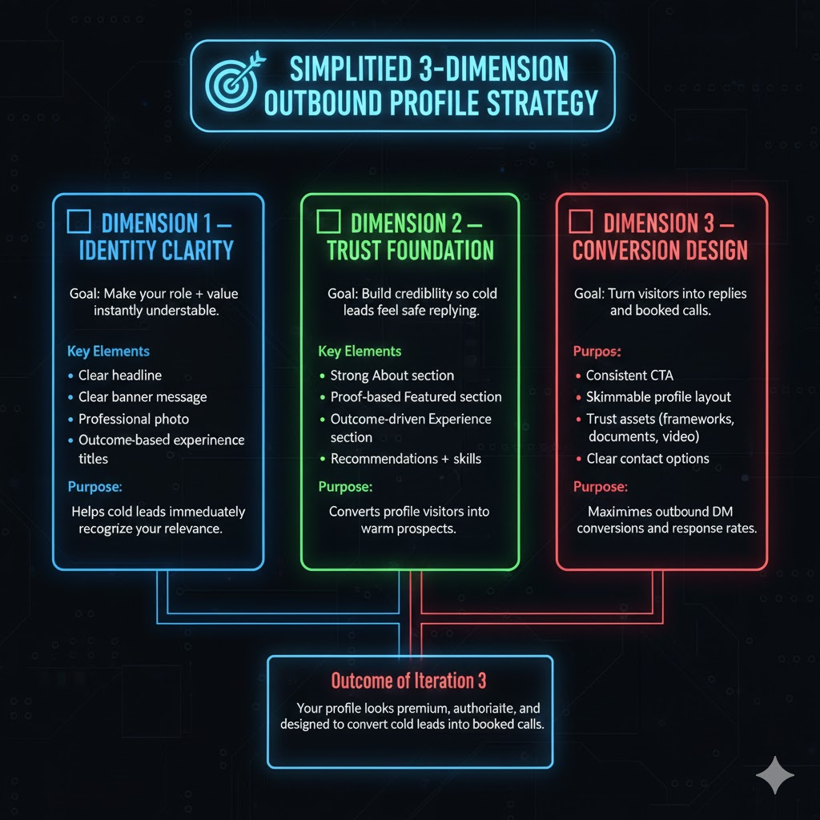

Network Building

N Iteration 1

⭐ ITERATION 1 — Foundation (Beginner)
Goal: Build a clean, relevant network that supports outbound.

1. Simple ICP (Ideal Client)
- Who: founders, CEOs, business owners
- Industry: pick one niche
- Company size: choose 1 segment (1–20 / 20–100)

2. Build a Relevant Network
- Connect only with
  - Founders & CEOs
  - CMOs
  - Agency owners
  - Coaches/consultants
  - Senior decision-makers
- Daily target: 10–20 connections

3. Follow the Right Profiles
- Founders in your ICP
- 2–3 niche creators
- People who already sell to your ICP

4. Light Daily Engagement
- Comment on 3 founder posts
- Comment on 2 niche creators
- Like 10–15 ICP posts

5. Profile Setup for Outbound
- Clear headline
- “Who you help” in About section
- Professional banner + sharp photo
Outcome: A clean, relevant network aligned for outbound success.

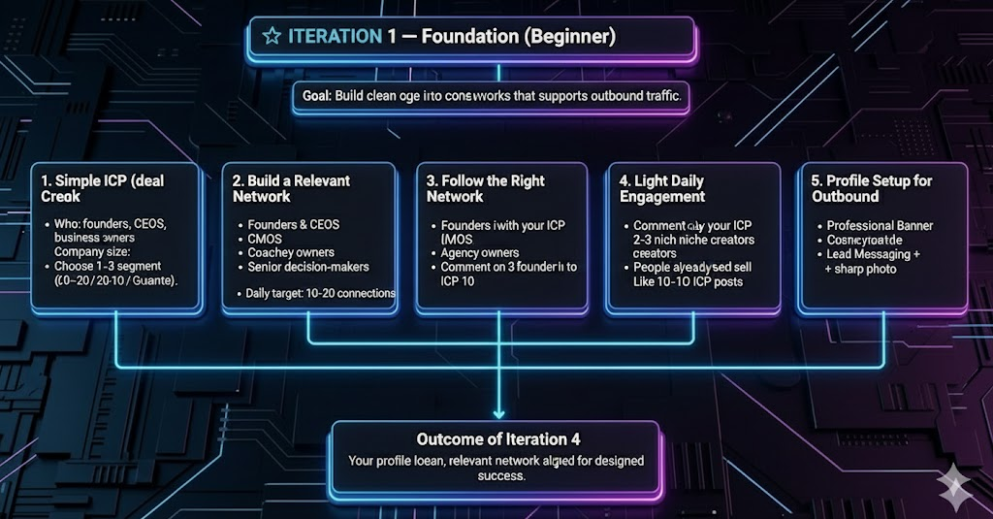

N Iteration 2

⭐ ITERATION 2 — Strategy (Intermediate)
Goal: Make your network targeted, intentional, and algorithm-friendly.

1. Refined ICP
- Sub-industry
- Revenue bracket
- Pain points
- Growth stage
- Tech stack (optional)

2. Three-Category Daily Connections
- ICP (buyers): 15–20/day
- Node Accounts (creators influencing ICP): 5/day
- Industry professionals: 5–10/day

3. Follow → Engage → Connect
- Follow
- Light engagement
- Send request

4. Build a “Founder Feed”
- Unfollow irrelevant accounts
- Mute noise
- Engage only within your niche

5. Strategic Engagement
- 5 ICP post comments
- 3 respected creators
- 3 industry professionals
- 10–15 future prospects
Outcome: Higher visibility, more trust, better outbound replies.

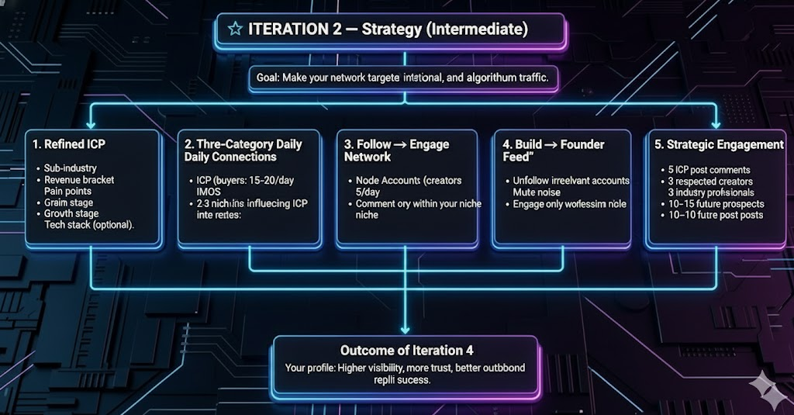

N Iteration 3

⭐ ITERATION 3 — Optimization (Advanced)

Goal: Build a high-performance network engine that compounds visibility.

1. Mini ICP Segments

High-urgency buyers

Scaling companies

Broken systems

Weak messaging

Warm ICP (engaged before)

2. Audience Mapping

Connect with people who influence buyers:

Investors

Advisors

Consultants

Partners

Operations leaders

3. High-Value Commenting

Insight + mini lesson

Pattern disruption

Simple frameworks

Subtle authority signals

4. Network Clusters

Cluster 1: ICP (buyers)

Cluster 2: Experts serving your ICP

Cluster 3: Mid-level creators

5. Weekly Network Maintenance

Remove irrelevant connections

Mute non-ICP

Re-engage people who engaged

Find newly active ICP

Maintain creator engagement loops

6. Warm-Up Before DMs

Profile view

Light engagement

Follow

Thoughtful comment

DM on day 3–4

Outcome: Maximum outbound conversions, trust, and ranking boosts.

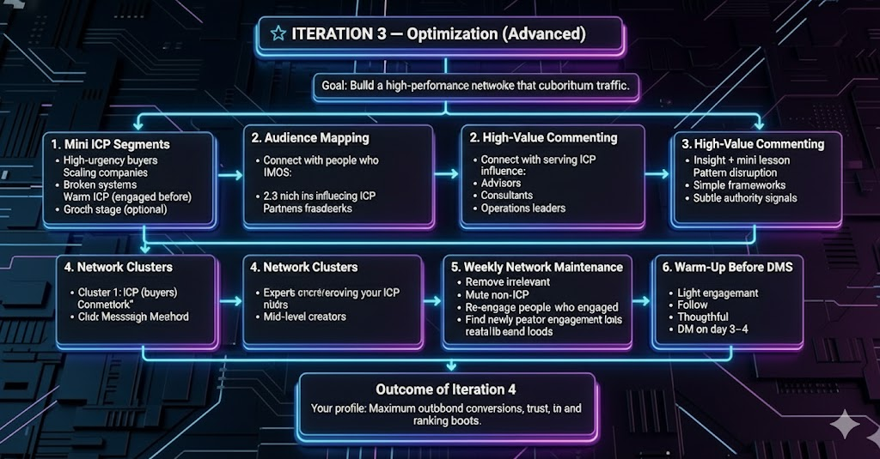

N Strategy

🎯 THE 3D NETWORK STRATEGY (Simplified)
(Depth • Direction • Distribution)

⭐ LAYER 1 — DEPTH (WHO)
Build a network with the right people.

1. ICP (buyers)
- Founders
- CEOs
- CMOs
- Agency owners
- Consultants

2. Adjacent Professionals
- Consultants serving your niche
- Sales, operations, marketing experts
- Fractional executives

3. Niche Creators
- Mid-level creators
- Educators
- Professionals respected by your ICP
Outcome: A high-quality, relevant network.

⭐ LAYER 2 — DIRECTION (HOW)
Grow intentionally—not randomly.

1. Daily Connection Targets
- 15 ICP
- 5 adjacent professionals
- 5 creators

2. Follow → Engage → Connect
- Follow
- Like/comment once
- Send request

3. Feed Curation
- Unfollow irrelevant accounts
- Mute non-ICP noise
- Engage only within your niche
Outcome: Predictable, strategic growth.

⭐ LAYER 3 — DISTRIBUTION (WHERE)
Show up where your ICP already is.

1. ICP Feed Presence
- Comment on 5 ICP posts daily

2. Engagement Clusters
- Cluster A: Buyers → recognition
- Cluster B: Creators → visibility
- Cluster C: Experts → expansion

3. Algorithm Positioning
- Consistent niche engagement
- High ratio of ICP connections
- Stay inside your topic lane
Outcome: Broad visibility across your ICP’s entire ecosystem.

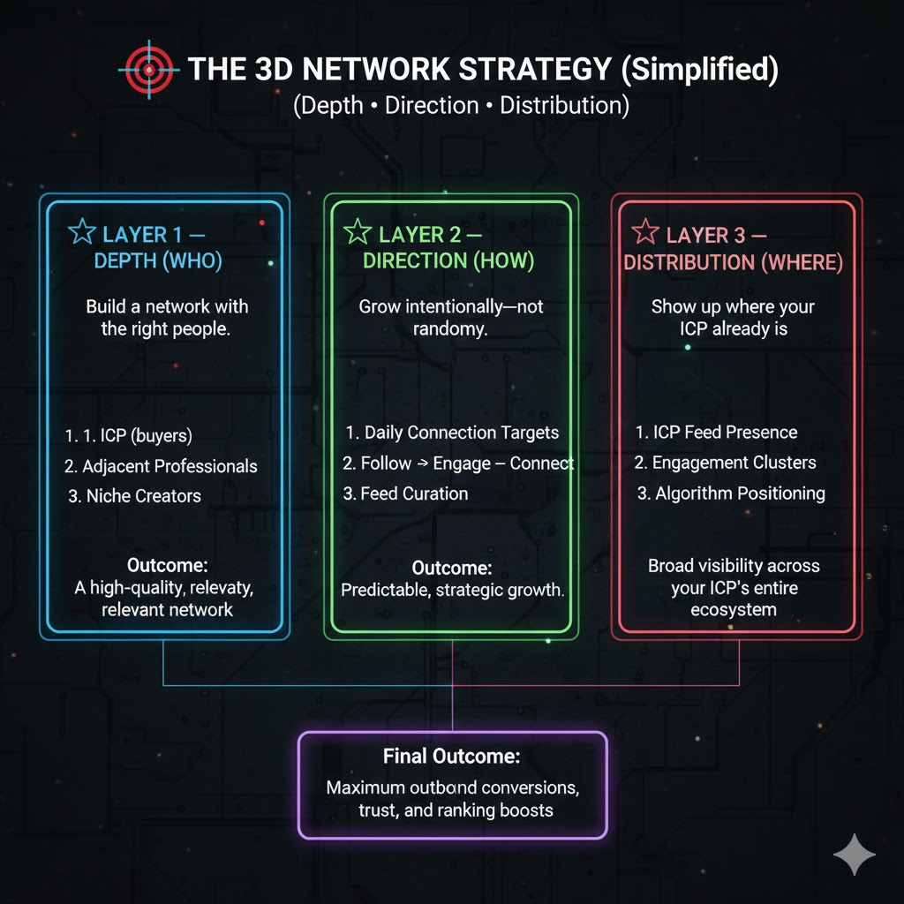

Content

C Iteration 1

⭐ ITERATION 1 — Foundation (Clarity + Consistency)
Goal: Build baseline authority and support outbound.

1. Core Content Types
- Problem Posts
  - Highlight what your ICP struggles with
  - Show real understanding
- Solution Posts
  - Simple frameworks, steps, checklists
  - Explain how solutions work
- Proof Posts
  - Wins, screenshots, before/after
  - Lessons learned from real work
- Personality/Insight Posts
  - Opinions, observations, personal lessons
  - Build relatability and voice

2. Simple Weekly Schedule
- Mon: Problem
- Tue: Solution
- Wed: Insight
- Fri: Proof

3. Tone & Style
- Short sentences
- Direct and punchy
- Clear structure
- Senior strategist voice
- No fluff

4. Goals
- Make your offer clear
- Show competence
- Build familiarity
- Support outbound messages

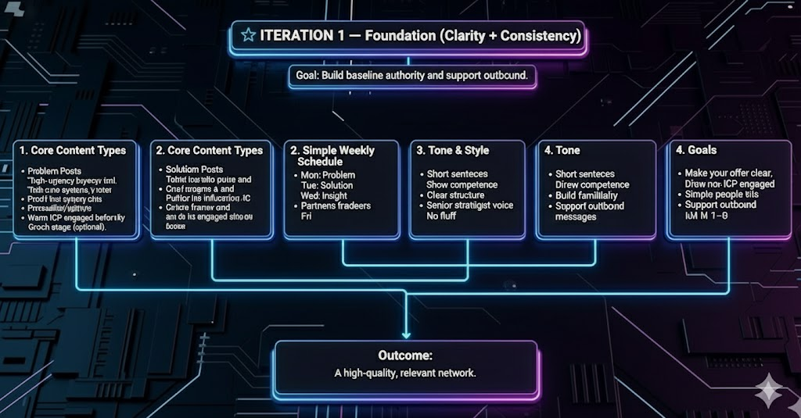

C Iteration 2

⭐ ITERATION 2 — Strategic & Funnel-Based
Goal: Shift from “sharing value” to “creating demand.”

1. Content Funnel (Buyer Journey)
- Awareness: show what’s broken
- Demand: reveal deeper gaps
- Desire: show the improved future
- Proof: results, experiences, case-style examples
- Offer/CTA: invite action naturally

2. Expanded Content Formats
- Framework posts
- Story posts
- Case-style posts
- Mistake → fix posts
- Carousel-style text posts
- Mini-breakdowns
- System-based content

3. Weekly Schedule (Strategic)
- Mon: Awareness
- Tue: Demand
- Wed: Framework
- Thu: Story
- Fri: Proof
- Sat: Offer/CTA

4. Narrative Style
- Introduce signature ideas
- Consistent angles
- Deeper explanation
- Original insights

5. Goals
- Build true authority
- Influence buying decisions
- Create content → DM flow
- Make your profile the natural next step

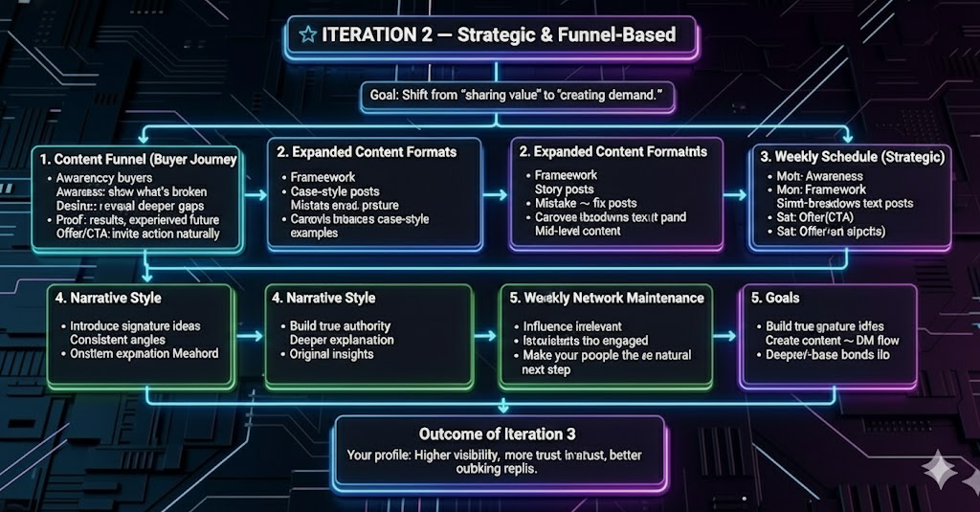

C Iteration 3

⭐ ITERATION 3 — Optimized & High-Authority
Goal: Build recognition, leverage, and a sustainable demand engine.

1. Signature Content OS
Pick 3–5 core pillars such as:
- Positioning & messaging
- Offer design
- LinkedIn strategy
- Outbound strategy
- Conversion psychology
Every post fits one pillar → creates brand ownership.

2. Authority Content Series
- Breakdown series
- Client mistake series
- Framework Friday
- Offer improvement series
Recurring themes = stronger identity.

3. Advanced Content Types
- Deep-dive breakdowns
- Contrarian insights
- Transformation-driven case stories
- Mini-diagnostics
- Buyer psychology content

4. Weekly Schedule (High Authority)
- Mon: Contrarian / Demand
- Tue: Framework
- Wed: Deep Breakdown
- Thu: Story + emotion
- Fri: Case study
- Sat: Offer
- Sun: Insight / Reflection

5. Messaging Rules
- Name your frameworks
- Repeat core ideas consistently
- Distinct “thought style”
- Pattern-breaking hooks
- Clear, quotable lines

6. CTA Integration
- DM keywords (“Profile,” “Fix,” etc.)
- Invite conversations naturally
- Announce availability or openings

7. Goals
- Become the recognized expert
- Increase inbound + warm leads
- Make outbound exponentially easier

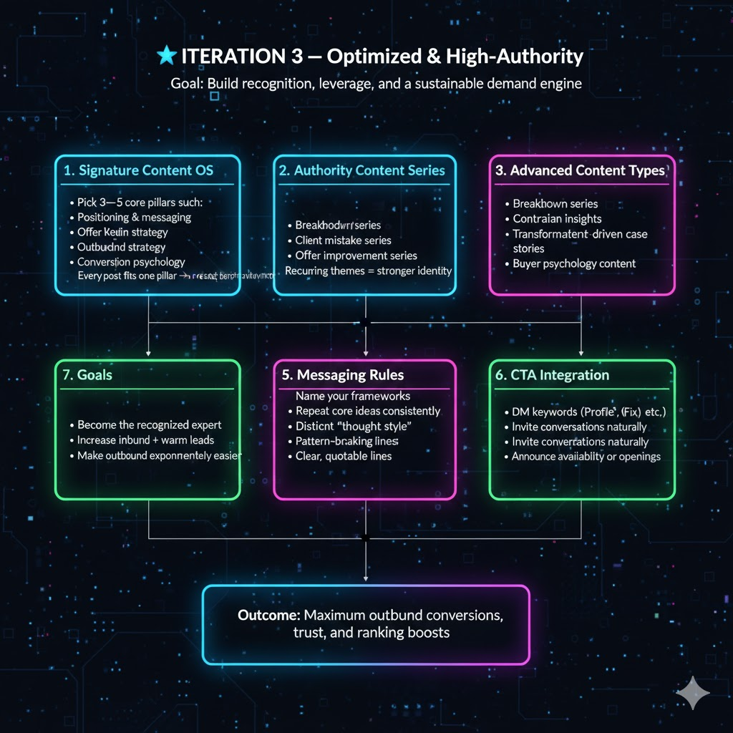

C .Strategy

🎯 THE 3-DIMENSION CONTENT STRATEGY (Simplified)
(Direction • Depth • Delivery)

⭐ DIMENSION 1 — DIRECTION (What You Say)
Purpose: Ensure all content aligns with your ICP and supports outbound.

1. Content Pillars
Choose 3–5 consistent pillars relevant to your ICP:
- Positioning
- Messaging
- Offer design
- LinkedIn strategy
- Outbound
- Psychology
- Proof/case studies
- Market insights

2. Buyer Journey Alignment
Every post moves the reader through:
- Awareness
- Demand
- Desire
- Proof
- Offer

3. ICP Relevance
Always write for:
- Founders
- CEOs
- CMOs
- Agency owners
- Consultants
Outcome: Clear, focused, purposeful posting.

⭐ DIMENSION 2 — DEPTH (How Smart It Is)
Purpose: Build authority by demonstrating expertise.

1. Problem Depth
- Hidden problems
- Root causes
- Industry mistakes
- Blind spots

2. Solution Depth
- Frameworks
- Systems
- Processes
- Step-by-step thinking

3. Insight Depth
- Industry patterns
- Psychology
- Strategic viewpoints
- Unique angles
- Real experiences
Outcome: Your audience sees you as a senior expert.

⭐ DIMENSION 3 — DELIVERY (How You Present)
Purpose: Maximize visibility, clarity, and conversions.

1. Structure
- Problem → Insight → Solution
- Mistake → Fix
- Before → After
- Story → Lesson
- Framework breakdowns
- Proof → CTA
- Short, skimmable formatting

2. Tone
- Direct
- Clear
- Senior
- Sharp
- No jargon

3. CTA Integration
- “DM me ‘Profile’”
- “If this fits you → let’s talk”
- “Want this done for you? Message me.”
Outcome: High engagement + smooth conversions.

